**Assignment- 2**

1. Determine the output, *X*, for a 2-input AND gate with the input waveforms shown in Figure-1.

Show the proper relationship of output to inputs with a timing diagram. Repeat for 2 input OR gate.

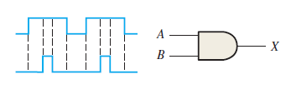Fig-1

1. The waveforms in Figure-2 are applied to points *A* and *B* of a 2-input AND gate followed by an inverter. Draw the output waveform.

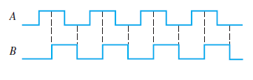Fig-2

1. Considering (Figure -2) A and B as two inputs, draw the output for 2 input OR gate, NOR gate , NAND gate, Exclusive OR , and Exclusive NOR.
2. The input waveforms applied to a 3-input AND gate are as indicated in Figure 3. Show the output waveform in proper relation to the inputs with a timing diagram. Repeat for 3 input OR gate

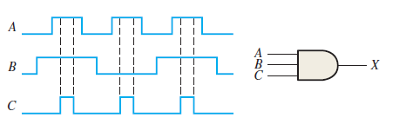Fig-3

1. The input waveforms applied to a 4-input AND gate are as indicated in Figure 4. The output of the AND gate is fed to an inverter. Draw the net output waveform of this system. Repeat for 4 input OR gate.

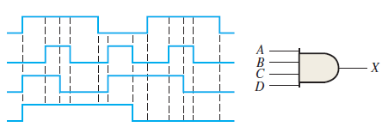Fig-4

1. For the waveforms given in Figure 5, *A* and *B* are ANDed with output *F*, *D* and *E* are ANDed with output *G*, and *C*, *F*, and *G* are ORed. Draw the net output waveform.

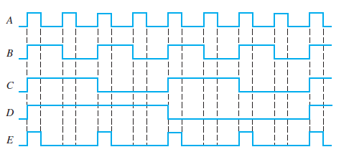Fig-5

1. As you have learned, the two logic symbols shown in Figure 6 represent equivalent operations. The difference between the two is strictly from a functional viewpoint. For the NAND symbol, look for two HIGHs on the inputs to give a LOW output. For the negative-OR, look for at least one LOW on the inputs to give a HIGH on the output. Using these two functional viewpoints, show that each gate will produce the same output for the given inputs.

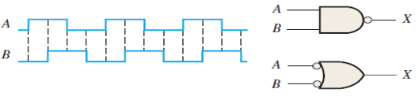Fig-6

1. Determine the output waveform in Figure 7 and draw the timing diagram.

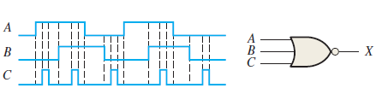Fig-7

1. The NAND and the negative-OR symbols represent equivalent operations, but they are functionally different. For the NOR symbol, look for at least one HIGH on the inputs to give a LOW on the output. For the negative-AND, look for two LOWs on the inputs to give a HIGH output. Using these two functional points of view, show that both gates in Figure 8 will produce the same output for the given inputs.

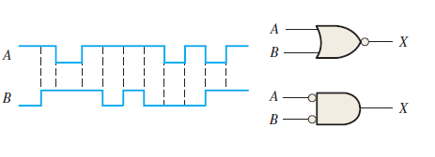Fig-8

1. Simplify the Boolean expressions:

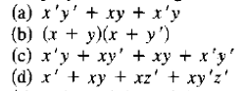

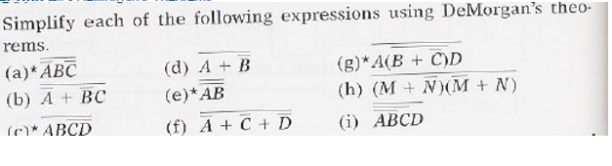

1. Use a Karnaugh map to find the minimum POS for each expression:

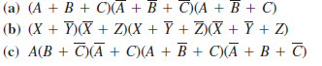

1. Use a Karnaugh map to simplify each expression to minimum POS form:



1. Convert each of the following POS expressions to minimum SOP expressions using a Karnaugh map:



1. Simplify the Boolean function : F(w, x, y, z) = Σ (I, 3, 7,11,15) that has the don't-care conditions : d(w, x, y, z) = Σ (0, 2, 5).
2. Simplify the following Boolean function F together with the don't-care conditions d; then express the simplified function in minimum SOP and minimum POS.

(a) F(x, y, z) = Σ(O, 1,2,4,5) d(x, y, z) = Σ (3,6,7)

(b) F(A, B, C, D) = Σ (0,6,8, 13, 14) ; d (A, B, C, D) = Σ (2, 4, 10)

(c) F(A, B, C, D) = Σ (I, 3, 5, 7, 9,15) ; d (A, B, C, D) = Σ (4, 6, 12, 13)

1. Simplify the expression for the output of the figure. Also draw the circuits diagram for simplified expression.

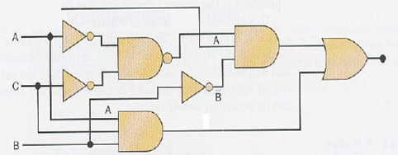

1. Simplify the circuit in Figure as much as possible, and verify that the simplified circuit is equivalent to the original by showing that the truth tables are identical.

